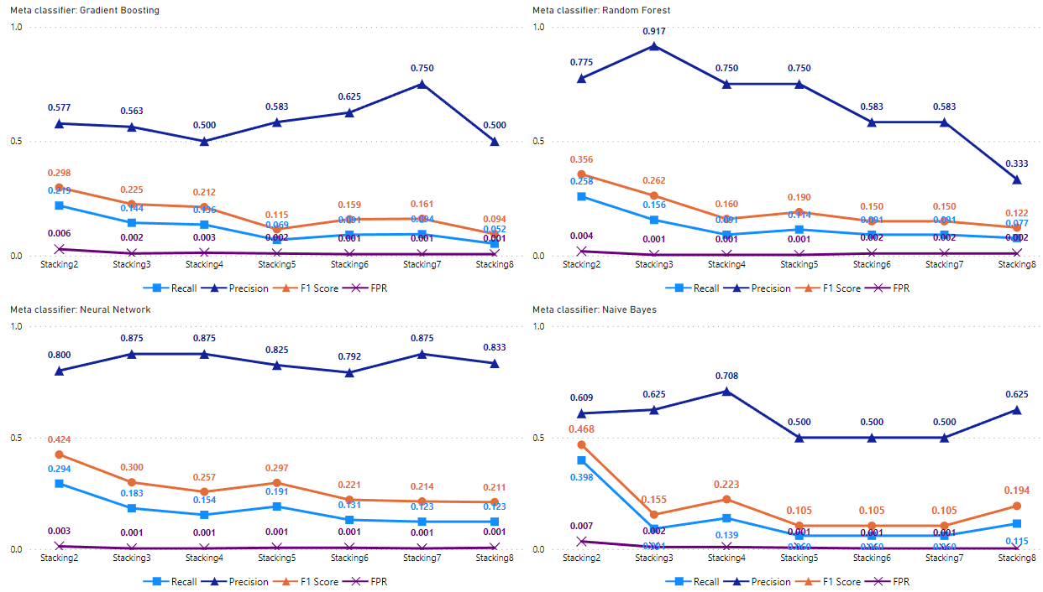  
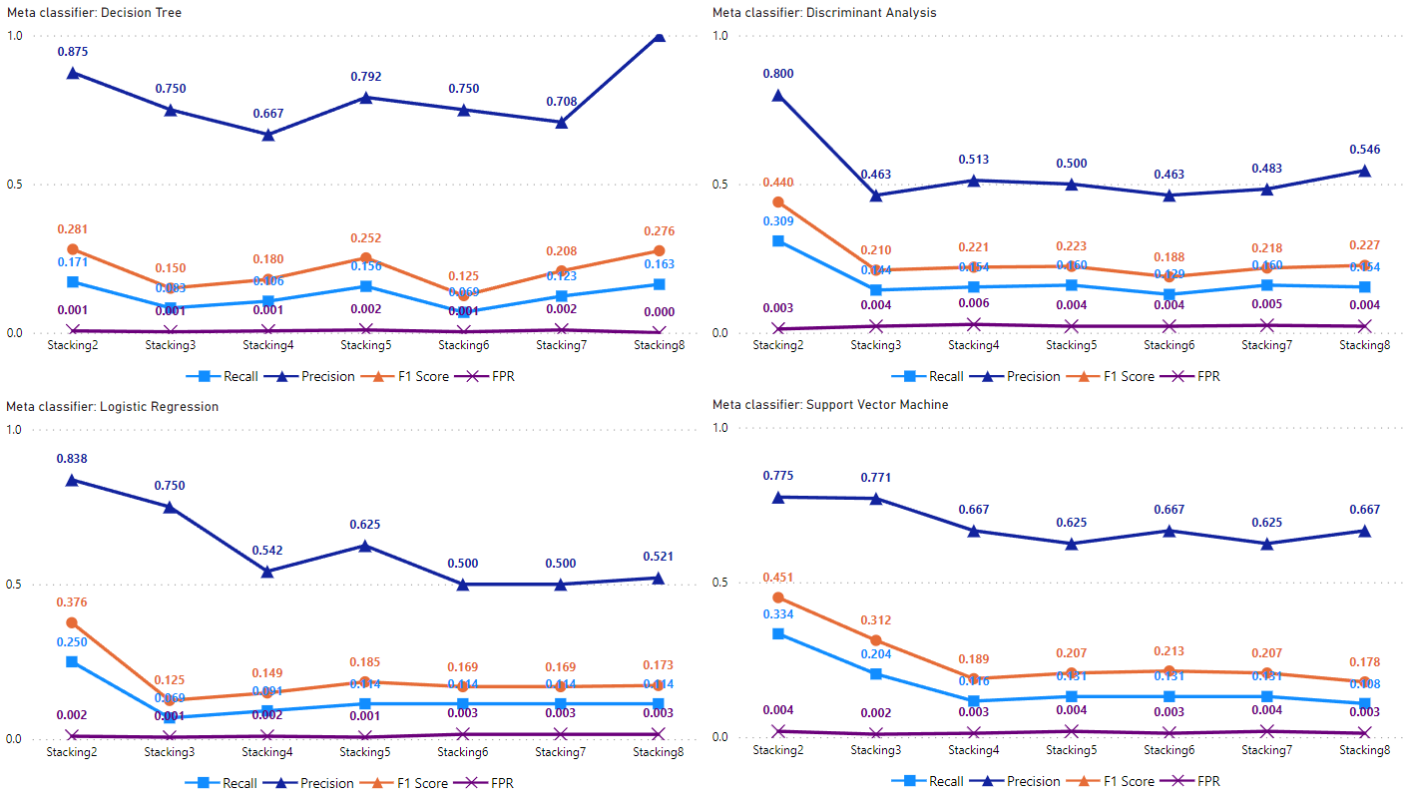

**Figure 13.** Stacking using different meta-models with seven different sets of rank-ordered base models based on item response, response time and summative statistics with a dual resampling ratio of 2:1 between the non-cheater and cheater classes.

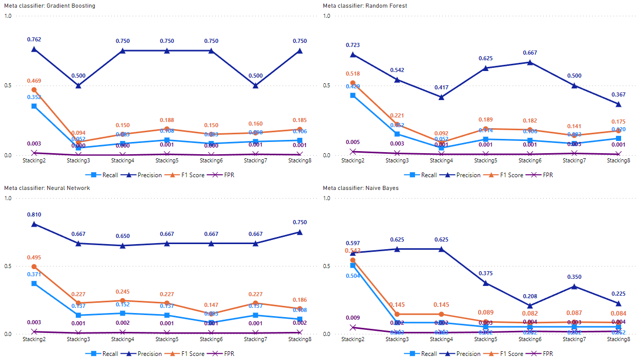  
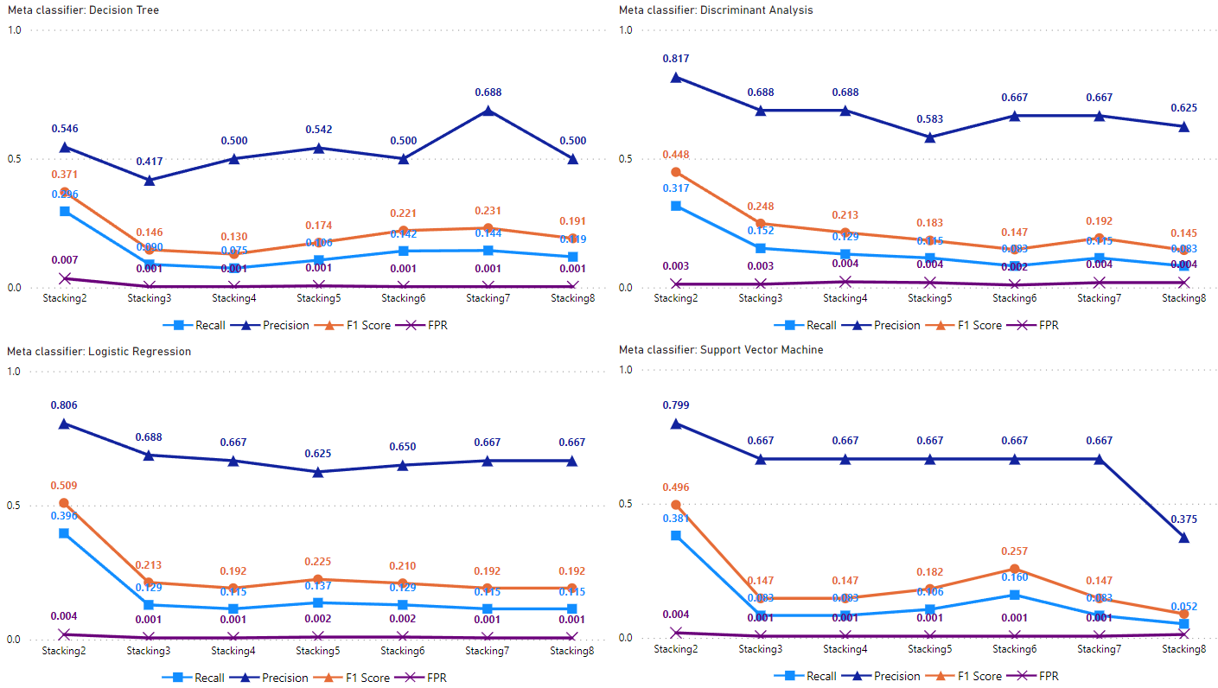

**Figure 14.** Stacking using different meta-models with seven different sets of rank-ordered base models based on item responses and summative statistics with a dual resampling ratio of 2:1 between the non-cheater and cheater classes.

**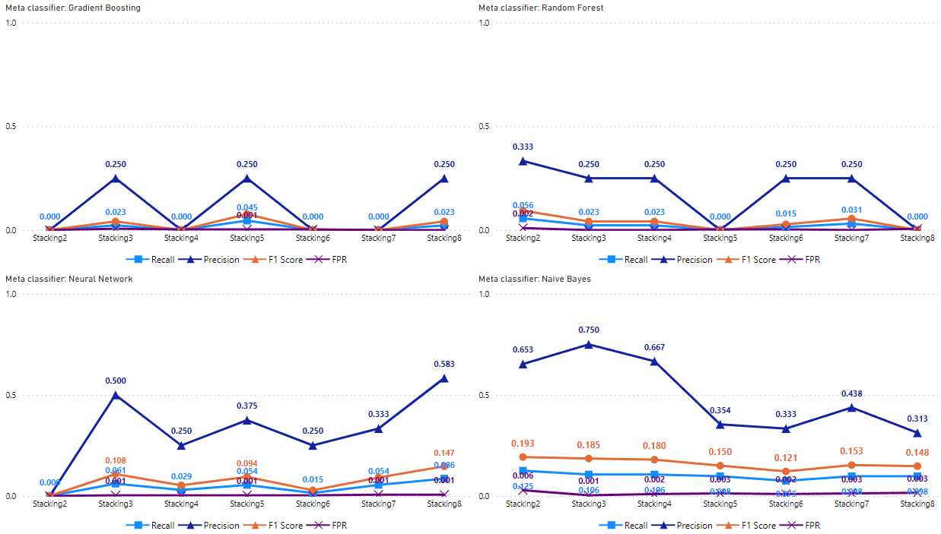  
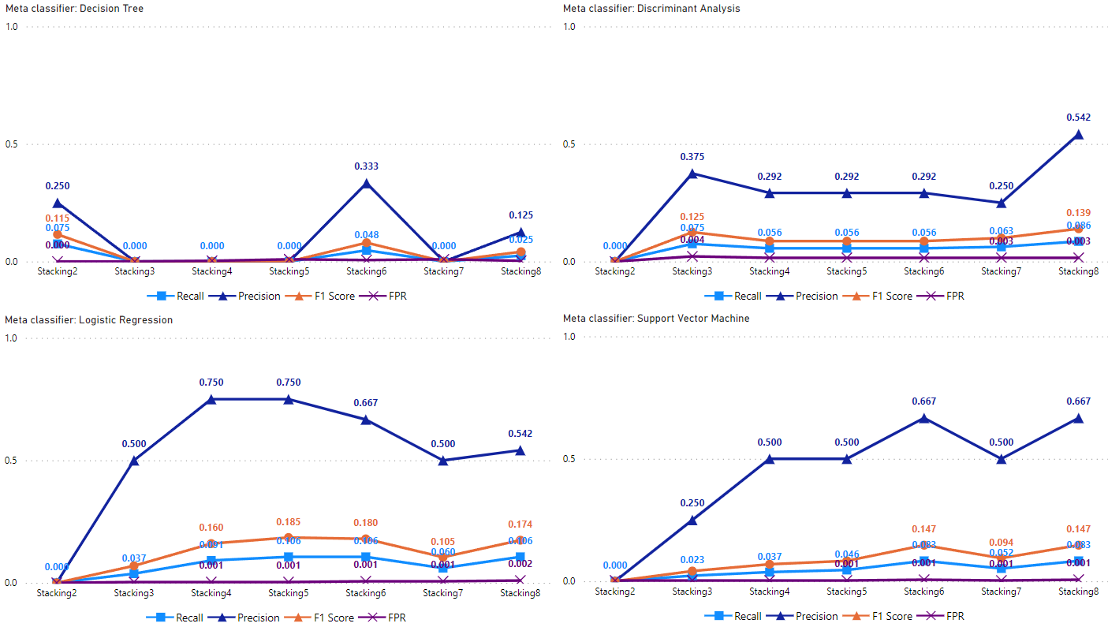**

**Figure 36.** Stacking with seven different sets of rank-ordered base models based on item response and response time with a dual resampling ratio of 2:1 between the non-cheater and cheater classes.

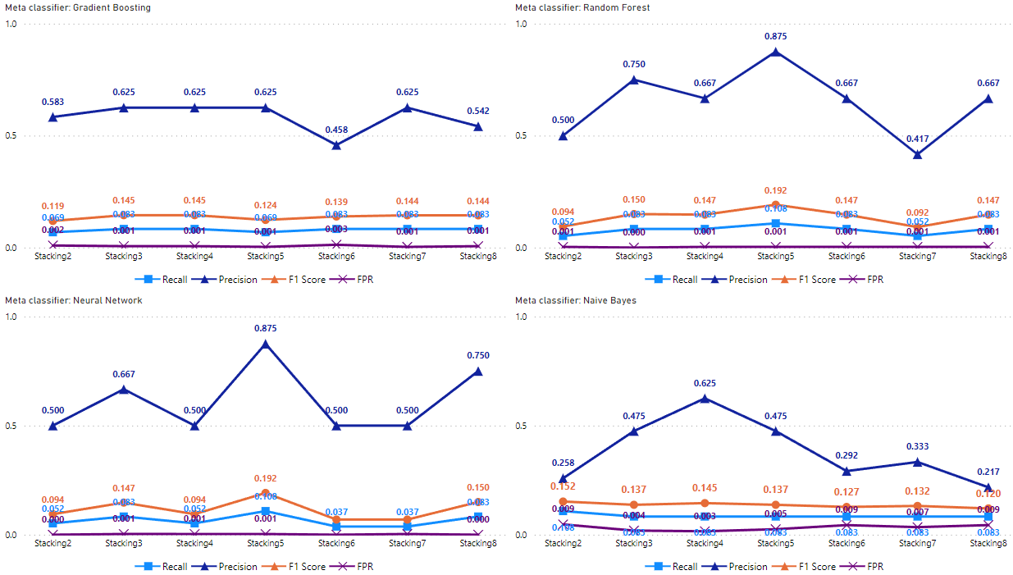  
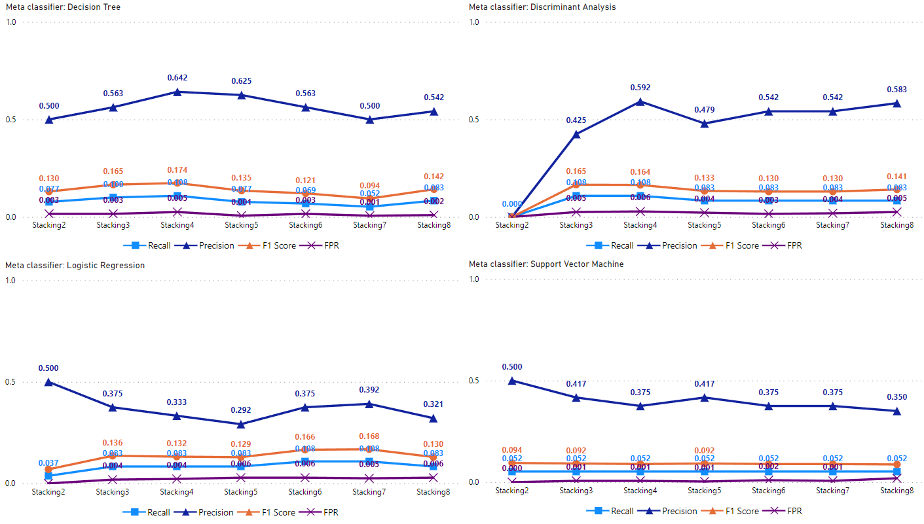

**Figure 37.** Stacking with seven different sets of rank-ordered base models based on item response with a dual resampling ratio of 2:1 between the non-cheater and cheater classes.

**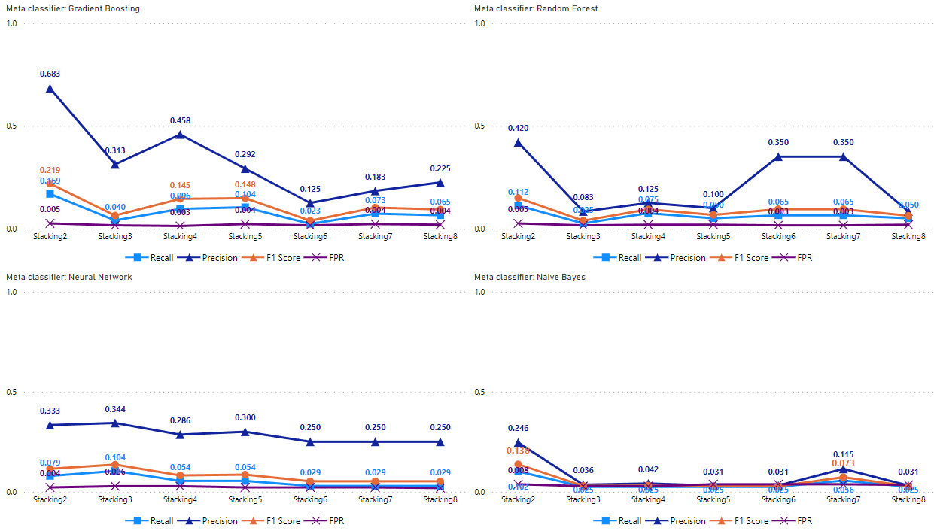  
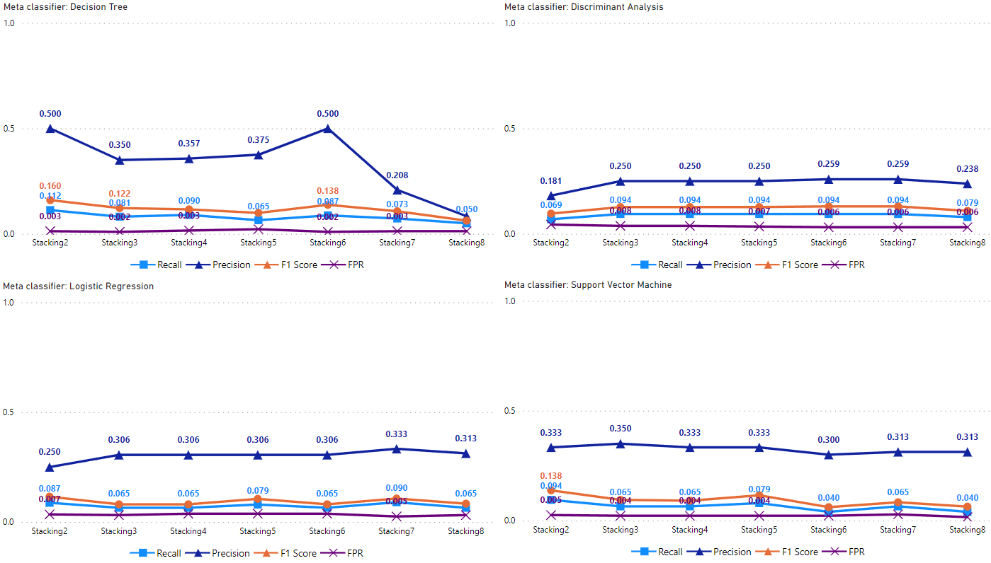**

**Figure 38.** Stacking with seven different sets of rank-ordered base models based on response time with a dual resampling ratio of 2:1 between the non-cheater and cheater classes.

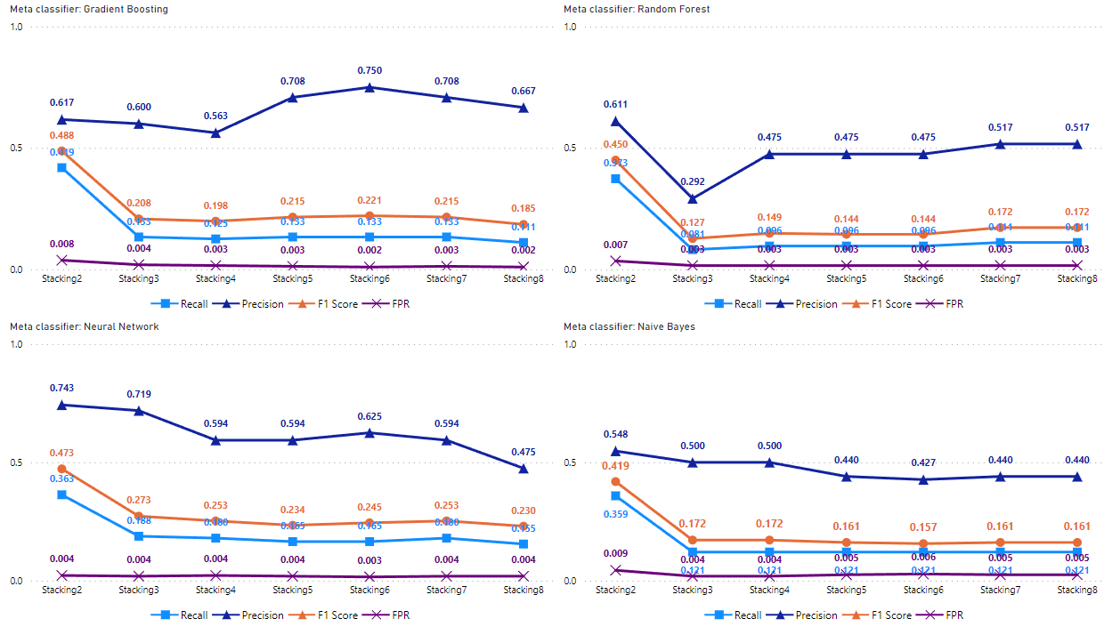  
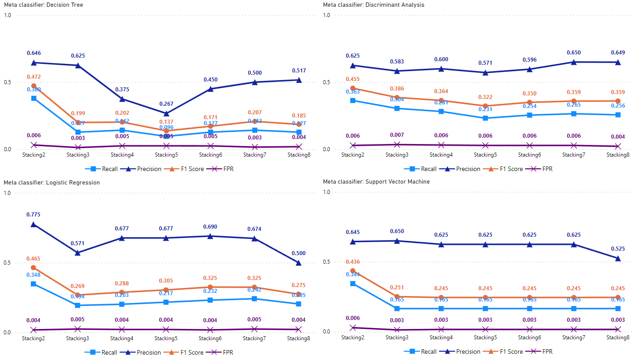

**Figure 39.** Stacking with seven different sets of rank-ordered base models based on response time and summative statistics with a dual resampling ratio of 2:1 between the non-cheater and cheater classes.